We have reserved space for your cargo （ 贵司在我司订舱已配好舱位） TO（订舱方）: 上海微谊供应链管理有限公司
Space No.（舱位号）: ZIHWB200419LH15
Consignor（发货方）: Shanghai Way-easy Supply Chain
Consignee（收货方）: I.O.T. BVBA
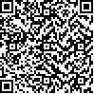Departure Date（班列日期）: 2020-04-19
Mark（唛头）: N/M
Originating Station(上货站): 郑州 Destination Station(下货站): 汉堡 Description of goods(品名): 旗子 Packaging(包装形式): 托盘
quantity(数量): 90
Weight(重量): 1500
Service No.(业务编码):

Container quantity and type（箱型箱量）:
LCL * LCL

size(尺寸): 38*36*28
Deadline(时间节点): Please deliver your cargo to
designated CY before the below specified time "A" (local time)
<货物请于以下“A” 规定时间节 点之前运到指定场站(当地时间
)>去程整柜和散货于班列发出日 前3天12点(其中周一和周日班列 为前4天12点)运到指定堆场
送货地址: 郑欧班列多式联运场站（河南省郑州市航海东路第十八大街与经北
四路交叉口东200米，郑欧商城进口商品体验中心向北500米）。 园区联系方式： 0371-55177817
园区工作时间: 周一到周日 8:00-11:30 14:00-18:00 跟单员: 张洒洒|张帅
A:送货到园区地址：
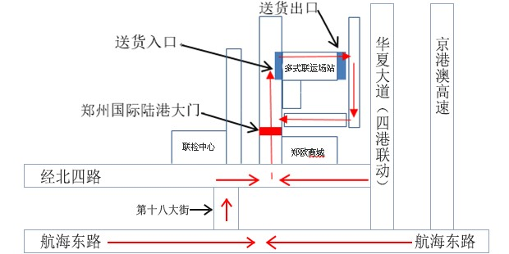
04 02, 2020

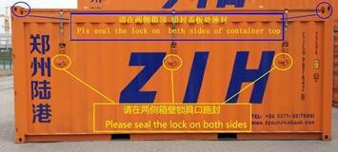
Zhengzhou Jutong-International Freight Forwarding Co., Ltd., as a carrier, our company is
responsible for the arrangements of international transport and the safety of cargo, booking party should ensure that the documents are in conformity with actual cargo. 郑州聚通国际货运代理有限公司作为承运人，负责货物的国际运输安排及安全，订舱方对实际发运货 物的单货相符负责。

Note : According to China customs regulations，please ensure the seal be locked at the 3rd Lock Handle with round rivet on the locking device of the container rear end ( from left to right). Please to Mark 3 on the pictures below. 备注：中国海关规定，封锁应锁到集装箱后方箱门左起第三根杆把手加锁处（有圆铆钉把手）。请参照下图标注的3号位置.
Warning ：A.Weight limit of the cargo in a 20' container is 21 tons. Weight limit of the cargo in a 40' container is 23 tons.
A.20呎柜货重限重21吨，40呎柜货重限重23吨。
B.If the single piece of cargo weighs more than 100KG, packaging details and loading photo must be provided. The container stuffing plan can be accepted only after the confirmation from ZIH. B.单件货重超过100KG,装箱前需提供包装明细和装箱照片。经陆港公司审核并符合铁路要求的，依照此方案进行装箱。 C.Security requirements of railway transportation：Cargo's center of gravity should be placed in the center of the container. Unbalance loading and over loading is unacceptable,for example, one side of the container is heavier than the other side, or one end of container is heavier than the other end. If the container is unbalanced or over loaded, we will need to do the container stuffing again. The related unstuffing and stuffing fees (Resulting in an additional operating cost of 150 dollars) incurred shall be at the booking party's cost.
If there is a shift packing of goods, dumping, spilling and other safety hazards, the goods reinforcement must be handled in accordance with the requirements of ZIH and ZIH can provide on-site technical packing service. C.铁路运输安全要求：货箱重心必须居中，绝对不能偏载、偏重、超重。不可出现货箱一头重一头轻或者一侧重一侧轻的偏载现 象。如发生以上偏载、偏重、超重现象，必须将货物掏出来重新装箱，所产生的掏、装箱等相关费用（导致额外的操作成本为
150美元），由订舱方自行承担。若装箱货物存在移位、倾倒、溢出等安全隐患的，必须按照陆港公司的要求对货物进行加固处 理，我司提供现场装箱技术服务。
40尺开顶箱：2个侧壁，每侧侧壁4个锁杆需要4个锁具，每侧箱顶需要3个锁具，箱门需要1个锁具 。一共15个
20尺开顶箱：2个侧壁，每侧侧壁2-3个锁杆需要2-3个锁具，每侧箱顶需要2个锁具，箱门需要1个锁具 。一共是9个或者11个
40OT: Two sides, four locks on each side, 3 locks on the container top of each side and 1 lock on the door, totally 15 locks.
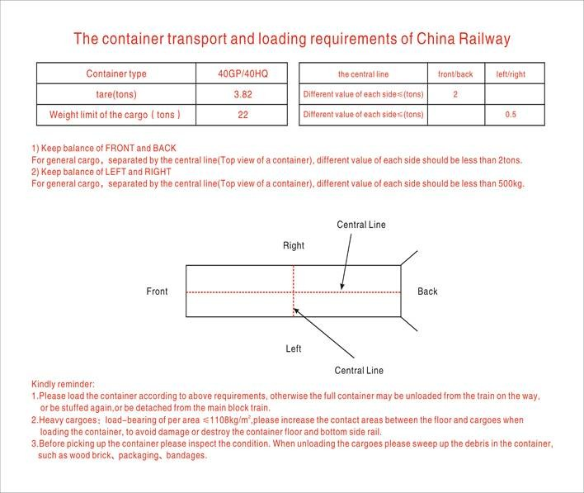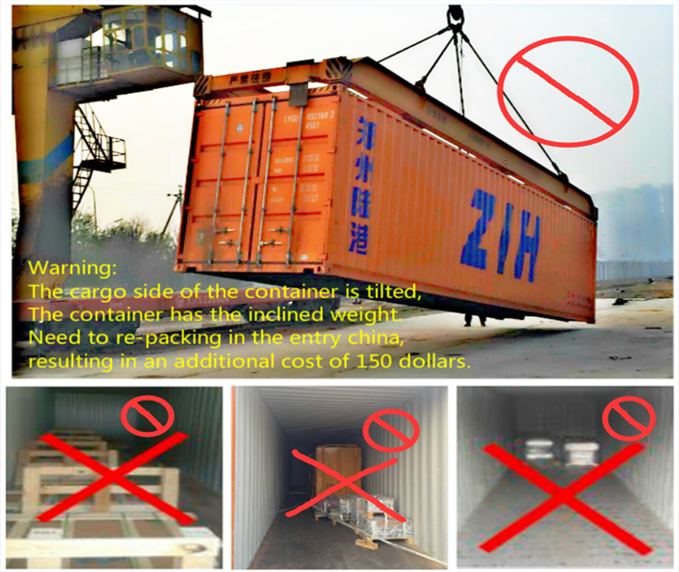20OT: Two sides, 2 or 3 locks on each side, 2 locks on the container top of each side and 1 lock on the door, totally 9 or 11 locks.
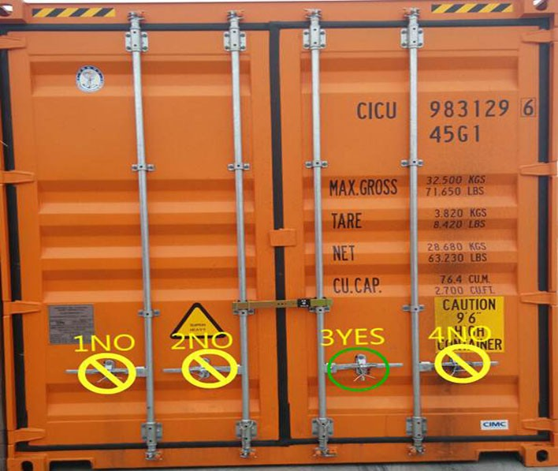

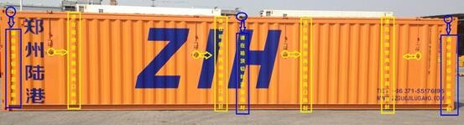

Note :Please deliver the bulk cargo to the designated terminal with this document and hand it over to personnel in terminal. 备注：请在送货到指定场站时携带本文件，并交给场站工作人员。
Note : If you would cancel this booking, please notify us 7 days before train departure. Or else, ZIH will charge you for dead freight. 备注：如果取消订舱请于班列开行前7天通知，否则陆港公司会收取亏舱费。
04 02, 2020

